**Source 1**

In 1987, US president Ronald Reagan visited Italy for a multilateral economic summit. On his way home, he stopped for a brief visit to West Berlin, the second of his presidency. Reagan was scheduled to address West German dignitaries and citizens at a ceremony to commemorate the 750th anniversary of Berlin. The location of this ceremony was the Brandenburg Gate, a huge archway that had served as one of Berlin’s main entrance points since the late 1700s. But since the construction of the Berlin Wall, the Brandenburg Gate had been closed. A lectern and red carpet was positioned outside the gate, while US Secret Service agents erected large panes of bulletproof glass, to protect Reagan from snipers in East Berlin. At 2pm on June 12th, Reagan welcomed the 45,000 people present – as well as “those listening throughout Eastern Europe, [to whom] I extend my warmest greetings and the good will of the American people.” Reagan then turned his attentions to the Soviet Union, highlighting its commitment to huge nuclear arsenals despite being unable to feed its people. Reagan also focused on Soviet leader Gorbachev’s recent proclamations of reform – glasnost and perestroika – pondering whether these were genuine or just a token effort to appease Western critics. Reagan then issued a challenge that became one of the best-known remarks of the Cold War:

“There is one sign the Soviets can make that would be unmistakable, that would advance dramatically the cause of freedom and peace. General Secretary Gorbachev, if you seek peace … if you seek prosperity for the Soviet Union and eastern Europe, if you seek liberalisation… Come here to this gate. Mr. Gorbachev – open this gate! Mr. Gorbachev – tear down this wall!”

**Source 2**

For world leaders such as Mikhail Gorbachev, Deng Xiaoping, George Bush, Helmut Kohl and Margaret Thatcher, the global battle of communism versus capitalism framed their entire world-view. Each recalled the struggles of World War II. Yet each had risen to power in the years that followed, believing their own society held the key not only to Cold War victory, but to the future itself. By the end of 1989 they would each come to realise what Thatcher had announced a year before: the world of their youths was gone. “We’re not in a Cold War now”, she told a sceptical American audience in December 1988. Because the Soviet Union had, in her opinion, ceased its quest for global domination, the Cold War was “all over but the shouting”.  
**Jeffrey A.Engel, historian**

**Source 3**

The death of the Soviet Union snuffed out the last embers of the Cold War. Though communist regimes remained in power in China, North Korea, Cuba and other smaller nations, the threat of Soviet imperialism and oppression had been lifted from the world. Some hailed Mikhail Gorbachev and other reformist leaders in the Soviet bloc as the architects of this. Others claimed that strong-minded Western leaders like Ronald Reagan and Margaret Thatcher had ‘won’ the Cold War. Others still said that communism had simply fallen victim to its own false promises; it was an unsustainable economic theory that collapsed from within. All are probably true to some degree – but in the tumultuous late 1980s, the final engine of change was the people. For decades they had lived in the shadows of communism: given little or no say in government, forced to work, oppressed and silenced. The final days of the Cold War were defined by ordinary people, who risked their lives to rejoin the free world, an idea expressed by novelist John Le Carre:

“It was man who ended the Cold War, in case you didn’t notice. It wasn’t weaponry, or technology, or armies or campaigns. It was just man. Not even Western man either, as it happened, but our sworn enemy in the East, who went into the streets, faced the bullets and the batons, and said: ‘We’ve had enough’. It was their emperor, not ours, who had the nerve to mount the rostrum and declare he had no clothes. And the ideologies trailed after these impossible events like condemned prisoners, as ideologies do when they’ve had their day.”

[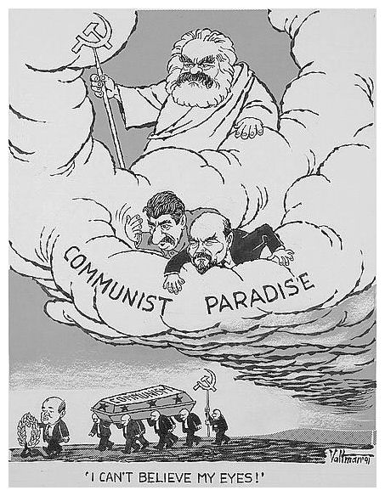](http://www.google.com.au/url?sa=i&rct=j&q=&esrc=s&source=images&cd=&cad=rja&uact=8&ved=2ahUKEwjBw8aJ4-raAhUNOrwKHe3AAAoQjRx6BAgBEAU&url=http://alphahistory.com/coldwar/glasnost-and-perestroika/&psig=AOvVaw37fMt42v9nWpcszFrcb95q&ust=1525477674403419)

**Source 4**

**Cartoon by Edmund Valtman, 1991.**

Edmund S. Valtman (1914-2005) may be the only American cartoonist of the Cold War era who experienced Soviet rule firsthand. The Pulitzer Prize winning cartoonist was working as a draftsman in his native Estonia when the Soviets overran the Baltic states in 1940. Russia went to war with Germany in 1941 and subsequently mobilized Estonian men under fifty, including Valtman's two brothers, to the Soviet Union. Germany occupied Estonia for three years until the Soviets re-occupied the beleaguered nation. These tumultuous events and their repercussions marked Valtman profoundly–ultimately bringing him to American shores and sharply shaping his anti-Communist stance on Cold War issues in his cartoons.